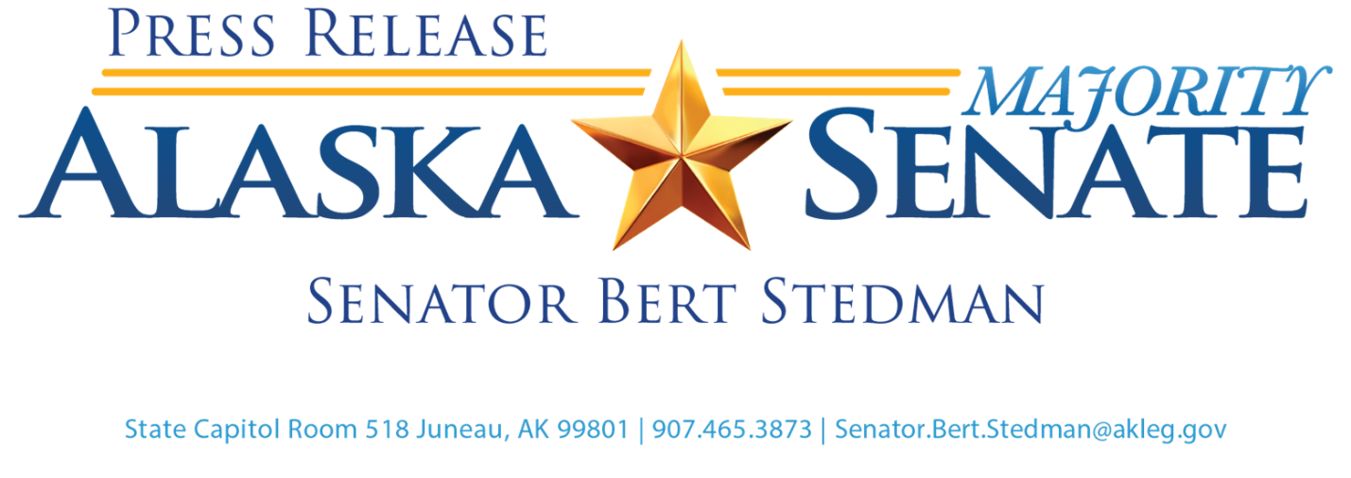

For Immediate Release: April 7, 2021

**Ketchikan NOAA dock project to begin, contract awarded**

JUNEAU – NOAA has awarded a contract to revitalize its port facility in Ketchikan, Alaska so that the NOAA Ship *Fairweather* can finally be homeported there.

“I’m happy that our congressional delegation was able to make this happen,” Senator Bert Stedman, R-Sitka, said. “I want to especially thank Senator Dan Sullivan and his office for helping secure this project that will help rebuild the NOAA dock in Ketchikan so that the NOAA Ship Fairweather can be permanently based there. This project has been in the works for over 20 years. It might have fallen through the cracks if it were not for the diligent teamwork by Senator Sullivan and his office, NOAA, and my former chief of staff, Randy Ruaro, who currently serves as Governor Mike Dunleavy’s chief of staff.”

Under the terms of the $18,771,041 contract, the Alaska-based company will make major improvements, including the construction of a new office building, large floating pier, steel access trestle, and updated power and water utility systems for servicing visiting ships. The project will begin with the removal of the existing pier and related structures.

Upon completion of this project, NOAA will have a fully functioning homeport in Alaska capable of supporting Ketchikan-based NOAA Ship Fairweather and other visiting NOAA and government vessels. NOAA expects the project to be completed by December 2022. This will bring jobs and development to our region in Ketchikan, which has been so hurt by the COVID-19 pandemic and loss of tourism and other business revenues.

“I’m very glad that after years of pushing this project, it’s finally ready to break ground,” Stedman said.

**HISTORY**: In 2001, federal law sponsored by former Senator Stevens required the NOAA vessel Fairweather to be homeported in Ketchikan. NOAA owns uplands and a dock at 1010 Stedman Street in Ketchikan. The dock is old and unusable. Stedman sponsored an appropriation in 2012 of $7.5 million in state general fund dollars to the Borough for a new NOAA homeport facility. In 2018, Sullivan added language to the USCG Reauthorization Act allowing NOAA to accept and spend non-federal funds to build a new dock for NOAA in Ketchikan. Then in 2020, the Ketchikan Borough transferred approximately $7 million to NOAA for the agency to take over the project and build the dock.

**ABOUT THE VESSEL**: The Fairweather is a hydrographic survey vessel that maps the ocean to support safe navigation and commerce. Officers, technicians, and scientists aboard the vessel collect data that NOAA cartographers use to create and update the nation’s nautical charts. The Fairweather was constructed at the Jacksonville Shipyards in Florida and christened in March 1967. The Fairweather was named after Alaska’s Mt. Fairweather. The vessel was commissioned by the U.S. Coast Guard and Geodetic Survey in October 1968 at the Pacific Marine Center in Seattle.

Press Contact: Mollie Barnes, Office of Senator Stedman, 907-465-1729, [mollie.barnes@akleg.gov](mailto:mollie.barnes@akleg.gov)